**Estimating abundance of aggregated populations with drones while accounting for multiple sources of errors: a case study on the mass nesting of Giant South American River Turtles**

**Abstract**

1. Counting animals when populations are spatially aggregated (e.g., breeding or nesting colonies, stopover or haul-out sites) enhances the accuracy and efficiency of survey efforts for abundance estimation. Orthomosaics generated from drone images are commonly used to count aggregated populations, but these counts are subject to detection errors that are often overlooked in abundance estimation.
2. Motivated by the need for a monitoring protocol for mass nesting events of Giant South American River Turtles, we develop a novel modeling approach to estimate the abundance of spatially aggregated wildlife populations using drone-based counts in orthomosaics while accounting for multiple sources of error. We use a combination of mark-resight data and overall population counts to account for: i) open population during the nesting event; ii) individuals unavailable for detection during flight; iii) double counts due to the orthomosaic building process; and iv) marked individuals detected in the mosaic with unidentifiable marks.
3. From the mark-resight data, we estimated that an individual has a probability of 0.37 to nest in each day, an availability probability of 0.35, an average proportion of double counts of 20%, and a probability of identifying the mark of 0.78. Using these values, we estimated a total population size of ~41,000 turtles using the sandbank during 12 days of the mass nesting season.
4. *Synthesis and applications*: The developed approach can be applied to several contexts to efficiently survey spatially aggregated populations using drone-derived orthomosaics, and to understand the phenology in these aggregation sites. We provide general recommendations for planning surveys and discuss implementations of our approach using other types of marking methods and modeling assumptions.

**1. Introduction**

Abundance/population size is a fundamental variable in ecology and conservation, for instance, to study the dynamics of populations, predator-prey and interspecific interactions, as well as to assess the impacts of habitat conversion and global climate change. Moreover, by monitoring abundance through time, it is possible to detect and predict trends in populations of game, invasive, or threatened species, together with assessing the effectiveness of management actions to control or increase these populations (Butchart et al., 2010; Moussy et al., 2022). However, estimating abundance can pose significant challenges, particularly in vast and extensive areas where species occur at low densities, making it difficult to detect individuals and to obtain accurate counts. Thankfully, several wildlife species exhibit seasonal behaviors in which the individuals concentrate in small areas to rest, interact socially, mate, breed, and/or nest, providing a great opportunity for counting them (Brown, 2016). For example, waterbirds gather in nesting colonies (Jovani et al., 2016; Rolland et al., 1998), seals aggregate in haul-out and breeding sites (Hoekendijk et al., 2023; Procksch et al., 2020), birds jointly use stopover sites during long-distance migrations (Cohen et al., 2021; Schmaljohann et al., 2022), and turtles synchronously nest in sandbanks and beaches (Forero-Medina et al., 2021; Scheelings, 2023). Therefore, counting animals during these periods of spatial aggregation can significantly enhance the accuracy and efficiency of survey efforts for estimating and monitoring abundance.

Recently, drone-based surveys have emerged as an efficient and less-invasive method for sampling spatially aggregated wildlife populations (Christie et al., 2016; Linchant et al., 2015; M. B. Lyons et al., 2019). Using drones (also known as unoccupied aerial vehicles, UAV; or remotely piloted aircrafts, RPA) to count aggregated individuals from above has been shown to be more accurate and precise in comparison with ground-based surveys (Goebel et al., 2015; Hodgson et al., 2016, 2018; Ratcliffe et al., 2015), while also causing less disturbance to the animals (Krause et al., 2021). A common protocol used for drone surveys is to plan flights with a high overlap between successive photos and lateral strips, merging the collected images into a single orthorectified mosaic (i.e., orthomosaic; Westoby et al., 2012; Wolf et al., 2014). When sampling aggregated populations, these flights usually cover the entire area where individuals are gathered (e.g., a bird colony area, Weinstein et al., 2022; or a seal haul-out islet, Procksch et al., 2020).

Despite the advantage of surveying completely the area of interest, the process of counting wildlife individuals in orthomosaics during these aggregation events often introduces some unintended errors and abundance estimates might be substantially biased if these multiple sources of error are not properly addressed (Brack et al., 2018). For instance, an individual may not be observable in the collected imagery (i.e., unavailable for detection) by being hidden below vegetation, under water, or temporarily outside the flown area (e.g., foraging elsewhere). Additionally, even if the individual is observable in the images, a human observer or a detection algorithm can fail to detect it. Furthermore, animals that move during the drone flight can appear multiple times at different locations in the photos used to create the orthomosaic (Figure 1). An important characteristic is that these aggregations are usually temporary, with individuals arriving and leaving the area throughout the days. For example, during the nesting, breeding, or migratory seasons of birds and seals, individuals can arrive and depart from the colony area in different days throughout the season. This “open population” characteristic might lead to biased estimates of abundance if not accounted for. Worryingly, these errors are widely overlooked in abundance estimations derived from orthomosaic counts of drone-based surveys.

**Figure 1.** Example of double count of a marked turtle individual in the resulting orthomosaic from drone surveys.

Our goal in this article is to develop a novel approach to estimate abundance of spatially aggregated wildlife populations using drone-based counts in orthomosaics while accounting for multiple sources of error. The approach relies on the combination of two types of datasets: resights of marked individuals and overall population counts. This study was motivated by the need to estimate the abundance and elaborate a monitoring protocol for Giant South American River Turtles (*Podocnemis expansa*, referred onwards simply as “river turtles”) during the world’s largest known aggregation of freshwater turtles. Every year during the dry season, thousands of river turtles gather to nest in sandbanks and beaches of the Guaporé/Iténez River, along the Brazil-Bolivia border (Amazon basin). While these mass nesting events used to be common across the Amazon and Orinoco basin, populations have considerably declined mainly due to overexploitation for meat and eggs consumption, and these large aggregations are now rare (Forero-Medina et al., 2021). Previous methods for estimating river turtles’ population size relied on counting hatchlings once they emerge (and then extrapolating the number of females using the average number of eggs per nest), or visual counts of adult turtles from the ground (Alvarez, 2006). Counting hatchlings is an invasive and time-consuming method since it requires fencing the sandbank perimeter and manipulating a great number of hatchlings. Visual ground counts of adult turtles also present limitations due to the difficulties imposed by counting thousands of individuals that obstruct each other and are in constant movement. Recently, drones have been tested to survey river turtle populations (Fagundes et al., 2022), holding great promise as a standardized, precise, and efficient method for estimating population sizes during these nesting events. This is key for assessing population trends and the effectiveness of conservation actions for the species.

We apply the developed modelling approach to estimate the population of river turtles during a mass nesting event. We account for multiple sources of errors, such as individuals’ availability, individuals joining and leaving the local population during the sampling period, and double counts due to the orthomosaic building process. Although our approach was initially inspired by this specific context, the developed framework is very versatile and can be readily used or adapted to several different contexts in which aggregated populations are surveyed using a drone orthomosaic. We therefore discuss the applications and expansions of the developed method for other wildlife surveying scenarios.

**2. Methods**

***2.1 Study area***

The study was conducted in the Guaporé/Iténez River, one of the major tributaries of the Madeira River, in the Amazon basin (Figure 2). The Guaporé/Iténez stretches approximately 1,210 km, most of which run along the Brazil-Bolivia border. Annual precipitation in the area ranges between 1,500-1,600 mm, distributed in two distinct seasons, a rainy (December – May) and a dry (June – November) period (Pouilly et al., 2012). During the low water level season, large sandbanks and beaches emerge, which are used by freshwater turtles to nest.

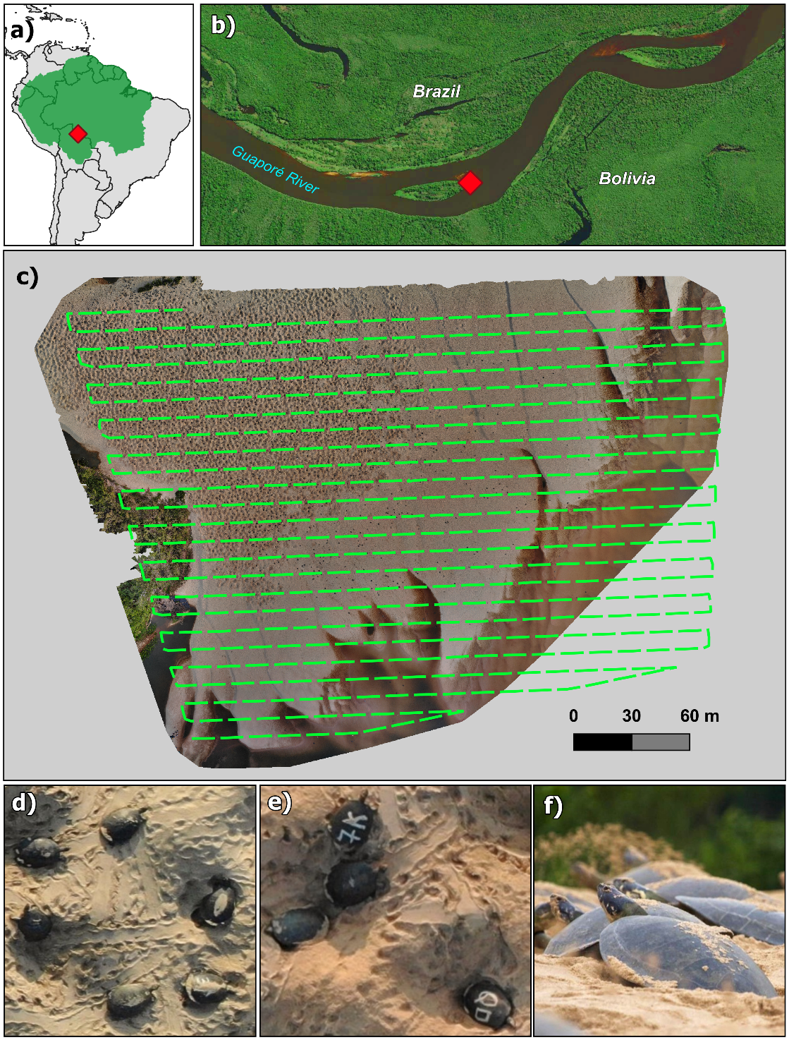

**Figure 2.** a) Location of the study area in the Amazon (green shadow). b) Sandbank in the Guaporé/Iténez River (Brazil-Bolivia border) where Giant South American River Turtles were surveyed. c) Planned drone flight path and resulting orthomosaic of the sandbank area during the turtle mass nesting event. d-e) Top-view of the turtles aggregating to nest in the sandbank. Some individuals were marked to allow the estimation of detection errors in counts. f) Ground-level view of the turtles nesting.

The Giant South American River Turtle is one of the most social of freshwater turtles (Ferrara et al., 2014), traveling the rivers in large groups, and gathering in front of the nesting sandbanks around July or August in this part of the Amazon. The female turtles nest synchronously in particular sandbanks that they select for this purpose (Alho & Pádua, 1982; Ferrara et al., 2010), starting when the water levels are lowest (September through November). The mass nesting event at the Guaporé/Iténez is the largest known for the species across its whole range (Forero-Medina et al., 2021). While river turtles may use several sandbanks to nest each year, we selected a particular one in 2021 (*Praia da Ilha*) to survey the population (Figure 2). This sandbank was the main nesting site for that year, concentrating most of the individuals and presenting the largest mass nesting. River turtles leave the water and enter the sandbank usually during the night. Some individuals nest that same night, while others explore the area to return on a different night to nest. An individual can enter the sandbank several times before nesting, and after nesting it does not return to the sandbank.

***2.2 Data collection***

Drone surveys were conducted daily between September 26 and October 04 of 2021, starting immediately after sunrise, around 6 am. We used a multirotor drone DJI Mavic 2 Enterprise Advanced carrying a 48 Mpx visible sensor. To cover the entire sandbank, we conducted four consecutive flight missions that took a total of approximately one hour to finish. We programmed the drone flights at 50 m above ground level, with 80% of frontal and 70% of lateral overlap. These flight settings resulted in a ground sampling distance (GSD) of 1 cm. We collected approximately 1,500 photos for the four flights in each day. Previous to each drone survey (around 3 am, while it was still dark), we marked approximately 100 individuals that were in the sandbank, painting unique symbols over their carapaces with white paint, with the goal of identifying them later in the drone images (Figure 2e).

The photos collected in each day were stitched together into daily orthomosaics using the OpenDroneMap™ software (<https://www.opendronemap.org/>) (Figure 2c). Two observers reviewed each daily orthomosaic in the QGIS software, using a grid to guide the search, and annotating all turtles detected. When the turtle had a mark in its carapace, it was identified when possible, or annotated as an unidentified mark (usually because the individual had sand on its carapace). Additionally, each detection (for both unmarked and marked individuals) was classified into either nesting or walking (see section 2.3). Nesting individuals could be distinguished from the walking ones as they were in the core area of the sandbank, within a hole in the sand and with their bodies tilted downward at the rear end. We did not include mark-resight data for September 30 (i.e., we only used the overall counts) because the poor quality in the resulting orthomosaic precluded the identification of marks.

We organized the mark-resight data into three subsets, one conventional multistate capture-recapture matrix and two compiled daily counts. The first subset was composed of the encounter history of each detected individual (encounter history matrix with individuals in rows and days in columns). We filled each row with 1, 2, or 3 if the individual was detected as walking, nesting, or not-detected, respectively. In the second subset, we tallied the total number of marked individuals that had their marks either identified or unidentified in each day. This subset was used to account for the bias resulting from marked individuals present in the orthomosaic but with marks not identified. In the third dataset, we compiled the number of detections corresponding to either unique individuals or repeated detections of the same individual (i.e., double counts) for each day, considering only the marked individuals classified as walking. Finally, aside from the mark-resight data, the other dataset was composed of the overall counts in the orthomosaic with the number of walking and nesting individuals detected each day.

***2.3 Model approach and fitting***

Using the mark-resight data and the overall counts, we developed a novel modelling approach to estimate the total abundance of aggregated populations while accounting for the following sources of variation:

1. Open population: individuals enter the sandbank for the first time on different days throughout the nesting event. These individuals can visit the sandbank multiple times before nesting but they do not return to the sandbank after nesting.
2. Individual states: an individual can be in either of two states in a given day: walking or nesting. Individuals walking are typically exploring the sandbank and can return in another day, while nesting individuals are usually sunken in the sand and do not return to the sandbank.
3. Unavailability: an individual that is part of the population can be outside the sandbank (i.e., in the water) during the drone flight and therefore will be unavailable for detection.
4. Double counts: some individuals that are walking during the drone flight can appear more than once in the orthomosaic.
5. Unidentified marks: it may not be possible to identify some individual marks because of sand obstructing them.

The proposed modeling approach has two components, one for the mark-resight data and one for the population count data (Figure 3). We provide a more detailed model description in the Appendix S1. The first component is a multistate open-population capture-recapture model for the mark-resight data (Calvert et al., 2009; Kendall et al., 2006; White et al., 2010), that was adapted to include the probability of identifying the mark of an individual and the proportion of double counts (mark-resight model in Fig. 3). Using a state-space formulation (Gimenez et al., 2007; Kery & Schaub, 2012), we modeled the biological state and the detection process of the individuals after the first capture (i.e., following the marking event) as categorical outcomes. The biological process is governed by the transition probabilities from the individual true state in time *t* to its state in time *t*+1 (Table 1a), while the detection level is defined by the probability of observing each state given its true state (Table 1b).

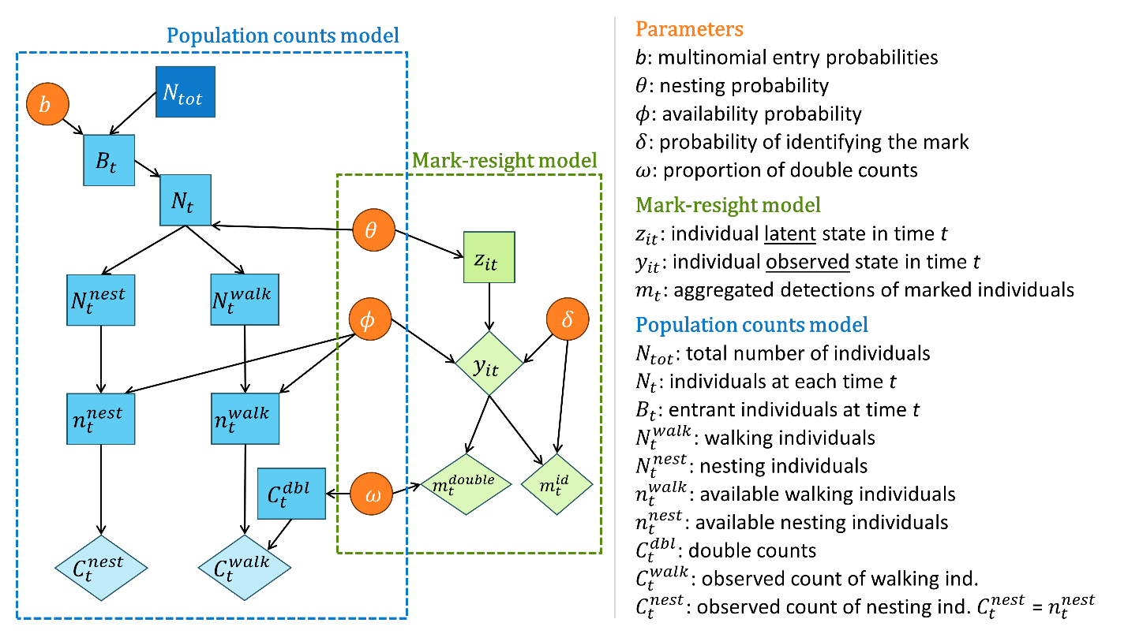

**Figure 3.** Directed acyclic graph for the combined modelling approach to estimate abundance from orthomosaic population counts and mark-resight data. Observed data, latent variables, and parameters are shown as diamonds, rectangles, and circles, respectively. Individual level mark-resight data are used to estimate parameters associated with the detection process and temporal dynamics of the overall population. The overall population counts are used to estimate the total population size with a remaining parameter of the entry process.

We considered that each individual can be in one of three different latent states at each day: 1 = walking (i.e., not nesting); 2 = nesting; and 3 = gone (i.e., already nested and left the area). Thus, a new marked individual is defined as walking in the moment of marking, and it has a probability $θ$ to nest in the next drone flight. An individual can remain in the population (with a probability of $1-θ$) and return to the sandbank multiple times before nesting. If the individual nests, it leaves the area and does not return (Table 1a).

**Table 1.** State-transition and detection matrices used in the mark-resight model. a) Individual transition probabilities from true latent states between time *t* and *t*+1. $θ$ = nesting probability. b) Probabilities of observing an individual in a given state given its true state. $ϕ$ = availability probability. $δ$ = mark identification probability.

|  |  |  |  |  |  |  |
| --- | --- | --- | --- | --- | --- | --- |
| **a) States transition matrix** | | | | | | |
|  |  | *True state at time t + 1* | | | | |
|  |  | Walking | | Nesting | | Gone |
| *True state at time t* | Walking | $$(1-θ)$$ | | $$θ$$ | | $$0$$ |
| Nesting | 0 | | 0 | | 1 |
| Gone | 0 | | 0 | | 1 |
| **b) States detection matrix** | | | | | | |
|  |  | | *Observed state* | | | |
|  |  | | Walking | | Nesting | Gone |
| *True state* | Walking | | $$ϕ_{j}δ$$ | | 0 | $$\left(1-ϕ_{j}\right)+ϕ_{j}(1-δ)$$ |
| Nesting | | 0 | | $$ϕ_{j}δ$$ | $$\left(1-ϕ_{j}\right)+ϕ_{j}(1-δ)$$ |
| Gone | | 0 | | 0 | 1 |

In the detection process, we modeled the probability of detecting a walking or nesting individual as a result of two process: the probability of the individual to be available on the sandbank area during the drone flight ($ϕ$), and the probability of identifying the mark ($δ$). Therefore, an individual is not detected because either it is not available, it is available but its mark was not identified, or it is already gone from the population (Table 1b). For the analysis of the turtle data, we separated the availability probability into two different parameters: i) $ϕ_{1}$: probability of an individual that was marked at 3 am to still be available for detection in the sandbank during the 6 am flight of the same day; and ii) $ϕ_{2}$: probability of an individual that was marked in one day and did not nest yet to be available for detection in a following day. The probability of identifying the mark ($δ$) was estimated using the additional count data, in which the number of individuals that had identifiable marks is a proportion of the total number of marked individuals detected on the orthomosaic that day. Finally, we estimated the probability of a detected walking individual to be a double count ($ω$) using the number of unique walking individuals with identifiable marks and the number of times these individuals appear in the mosaic.

For the second model (i.e., population counts model in Fig. 3), we used the overall population counts to estimate the total population size and parameters for the entry process. We used a superpopulation formulation considering that a total of $N_{tot}$ turtles use the sandbank at least once during the sampling period. Each individual of the total population $N_{tot}$ has a probability $b_{t}$ of entering in the population on each day, so that the sum of entries is equal to the total population size. The population size at each day ($N_{t}$) is composed of the number of individuals nesting ($N_{t}^{nest}$) and walking ($N_{t}^{walk}$), determined by the nesting probability ($θ$). In the following day, the nesting individuals leave the population, the walking ones remain, and new entrants arrive ($B_{t}$), so that $N_{t}=N_{t-1}^{walk}+B_{t}$ (for $t>1$; note that $N_{1}=B_{1}$).

In the observation level of the overall counts ($C_{t}^{tot}$), we assumed that, in each day, only a proportion of the nesting and walking individuals were available at the sandbank during the drone flight ( $n_{t}^{nest}$ and $n_{t}^{walk}$ respectively) with availability probability $ϕ$. We assumed that the number of nesting individuals that are available in the sandbank is perfectly observed (i.e., there are no double counts given that individuals are not walking). On the other hand, the number of walking individuals detected is composed of the true number of unique walking individuals that are available for detection and the number of double counts of walking individuals ($C_{t}^{dbl}$):

$$C_{t}^{tot}=C_{t}^{nest}+C_{t}^{walk}= n_{t}^{nest}+\left[n_{t}^{walk}+C_{t}^{dbl}\right]$$

The proportion of walking individuals detected that correspond to double counts is determined by the double count probability $ω$. Finally, we used vague priors for all the parameters (see details in Appendix S1).

We assessed the identifiability of the parameters under this model structure using simulation experiments (see tutorial in Appendix S2). We conducted the analysis using a two-step approach under a Bayesian framework using the Nimble package (de Valpine et al., 2017, 2024) in R (R Core Team, 2023). We first estimated the parameters for the mark-resight data, and then used random posterior samples of these estimates to model the overall counts (see details in Appendix S1). We assessed model convergence by visual inspection of traceplots and using R-hat statistics (Brooks & Gelman, 1998). Code to fit the model for simulated data and the river turtle dataset is provided at xxxxx.

**3. Results**

The overall turtle counts in the daily orthomosaic varied between 531 (373 individuals walking, 158 nesting) and 4,073 (1,934 walking, 2,139 nesting), resulting in a total of 26,532 individuals counted in the 12 days (Figure 5a). Out of the 1,187 individuals marked throughout these 12 days, 468 were recaptured at least once, 61 more than twice, and only 7 turtles were resighted more than three times. A total of 325 (69.4%) out of the 468 resightings of marked individuals occurred on the first occasion after marking (i.e., the individual was marked at night [3 am] and resighted at sunrise [6 am] on the same day). The proportion of marked individuals detected in each day that had identifiable marks varied from 63.6% to 87.2%. Finally, considering only the marked individuals with identifiable marks classified as walking, the proportion of double counts varied from 6.6% to 31.6%.

Regarding the parameters estimated in the mark-resight modelling component (Figure 4), we found that the probability of an individual to nest on each occasion is 0.369 (95% CI = 0.335-0.404). The probability of an individual that was present during the night to be available in the 6 am flight ($ϕ_{1}$) was estimated as 0.353 (95% CI =0.318-0.389). On the other hand, an individual that was marked and did not nest yet in one day had a probability $ϕ_{2}$ of 0.118 (95% CI = 0.096-0.141) to be available in a following day. The estimated proportion of double counts for the walking individuals ($ω$) was 0.197 (95% CI = 0.157-0.241) while the probability of identifying the symbol of a marked individual ($δ$) was 0.777 (95% CI = 0.745-0.807).

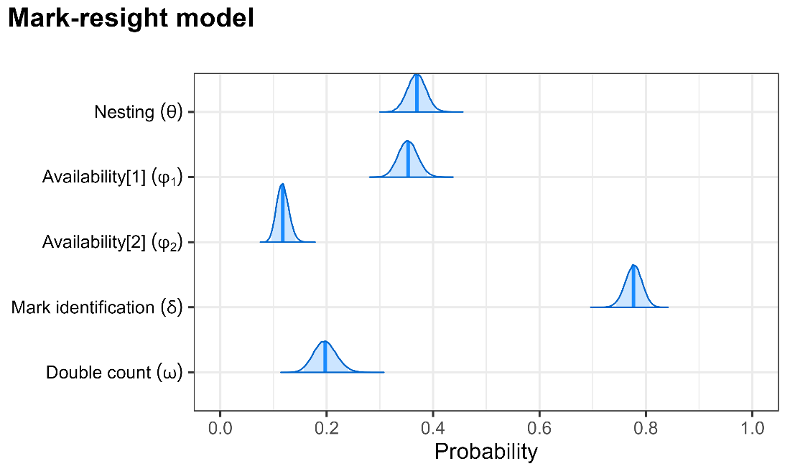

**Figure 4.** Posterior distribution of the probabilities estimated from the mark-resight data in drone orthomosaics of Giant South American River Turtles during a mass nesting event in the Guaporé/Iténez River (Amazonia).

For the overall counts, the total number of female turtles that used the sandbank during the 12 days was estimated to be 41,377 (95% CI = 37,246-46,026). The number of new individuals entering the population per day varied between 19 (95% CI = 0-70) and 9,691 (95% CI = 8,429-11,119) (Figure 5b). We observed a general increase in the daily population size throughout the days from around 3,000 to around 14,000 (Figure 5c).

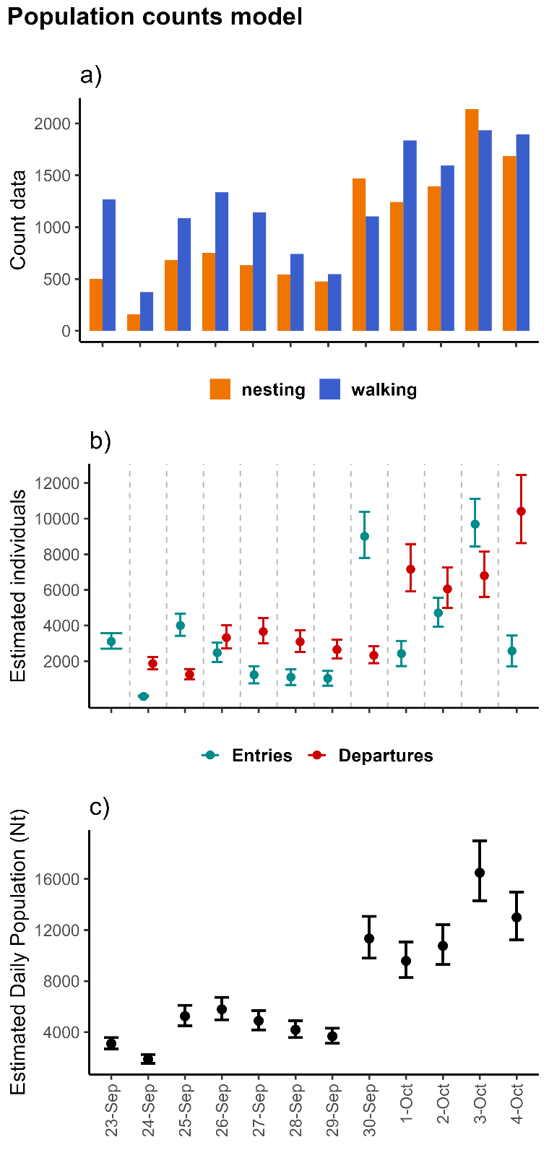

**Figure 5.** Population counts and resulting abundance estimates from orthomosaics of drone surveys of Giant South American River Turtles. a) Counts of nesting and walking individuals per day; b) estimated number of entrant and leaving individuals per day; and c) estimated daily population size.

**4. Discussion**

Seasonal aggregations of wildlife populations (e.g., haul-out sites, migratory stopover sites, nesting or breeding colonies) provide a great opportunity for efficiently estimating and monitoring abundance. Drone-based counts have been used to survey spatially aggregated populations (Christie et al., 2016; M. B. Lyons et al., 2019), but there has been little awareness of the multiple detection errors that may affect counts and consequently bias population estimates. We developed a model to estimate abundance of spatially aggregated population from drone-based counts in orthomosaics that accounts for multiple sources of false-negative and false-positive errors. Our approach relies on an individual-level dataset (mark-resight data) to estimate availability and double counts under an open-population multi-state capture-recapture model. We illustrate this approach by estimating the number of female Giant South American River Turtles during a mass nesting event. The use of orthomosaics generated from drone flights is becoming an increasingly common approach to survey aggregated wildlife populations and, for this reason, we believe the developed methodology has great potential to be applied (and adapted) to many different contexts.

To our knowledge, this is the first study to account simultaneously for multiple sources of bias in orthomosaic counts of drone-based surveys. While false-negative errors, such as the unavailability of individuals during the flight, are more commonly addressed in counts on aerial images (e.g., Brack et al., 2023), false-positive errors, such as double counts, are usually ignored or assumed to be insignificant (Brack et al., 2018; Elmore et al., 2023). Critically, using the river turtle example, we found that moving individuals can appear up to seven times in an orthomosaic, and that double counts can correspond up to 31.6% of the individuals walking. Furthermore, by using an open population approach with the superpopulation formulation, we were able to estimate the total population size throughout the entire study period. Accounting for this temporal dynamic can be imperative when modeling counts that arise from seasonal spatial aggregations of wildlife species. Interestingly, our approach can also be used to understand the phenology during the breeding or nesting season by modeling temporal trends in the arrivals and/or departures of individuals.

During model development, we identified some general recommendations for designing orthomosaic drone surveys to count spatially aggregated wildlife populations. First, if the goal is to estimate the total number of individuals that use the aggregation site throughout the season, it is important that the sampling time window encompasses the entire period in which the site is used by the target wildlife species. To be feasible, this may require conducting surveys on alternate days. However, note that if the substitution of the population is expected to be high for the specified time interval (i.e., too many entries and departures), increasing the time interval between surveys can be problematic. Furthermore, marking a subset of individuals before each drone flight (as we did) can provide better information about the temporal variability of the parameters compared to marking only once before starting the surveys. Nevertheless, because individuals marked in the initial occasions have longer encounter histories and thus may contribute with more information for the parameter estimation, one could prioritize marking more individuals in these first visits. Such type of sampling design optimization is an interesting topic for future research using simulation experiments.

The formulation of our proposed model resembles previous approaches that combined counts and mark-resight data (with banding/ringing) to model abundance with temporal dynamics in bird migratory stopover sites (J. E. Lyons et al., 2016; Matechou et al., 2013; Tucker et al., 2023). However, these former approaches did not include multiple states, the possibility of double counting individuals, and the presence of unidentifiable marks. Importantly, Matechou et al. (2013) explored the influence of double counting and unidentifiable marks using simulation experiments, and they concluded that not taking into account these sources of error can result in abundance overestimation. Another source of error that can be accommodated in our modeling framework is the possibility of misdetecting an individual nesting as walking, to account for individuals that appear in the orthomosaic walking before or after nesting. We briefly explored with simulations a version of the model that accommodates the misdetection of the state of the individual by including a specific misdetection probability in the detection matrix. The results of this model were promising, especially for scenarios in which several individuals are recaptured on multiple occasions after the marking. However, we did not consider this model formulation for the turtle data because the probability of misdetection was estimated to be very close to zero, suggesting that this type of misdetection is insignificant for this dataset.

The developed approach can be applied to other contexts in which spatially aggregated populations are surveyed using drone-derived orthomosaics. For instance, drones have been used to survey freshwater turtles in basking areas (Bogolin et al., 2021) and sea turtles in nesting sites (Rees et al., 2018; Thorson et al., 2012). Furthermore, orthomosaics are a common approach used in surveys of haul-out sites and nesting or breeding colonies of seals and birds (e.g., Goebel et al., 2015; Kellenberger et al., 2021; Korczak-Abshire et al., 2019; Procksch et al., 2023; Weinstein et al., 2022). Obviously, these different contexts may require some adaptations, such as other approaches to mark individuals. For example, seals were marked for drone surveys by clipping their fur (Sorrell et al., 2019), elks were attached with high-visibility collars to be resighted in aerial surveys (Bear et al., 1989), and different ungulate species have been marked with paintballs for aerial resighting (Pauley & Crenshaw, 2006; Skalski et al., 2005). Another important adaptation refers to which individual states to represent. In cases where all adult individuals are expected to have a similar temporal dynamic (i.e., no difference between states), our modelling framework could be simplified to represent only two states: present and gone. However, some aggregated populations can present different temporal behaviors between adult males and females (and possibly juveniles) (e.g., Dujon et al., 2021; Infantes et al., 2022), potentially requiring the use of sex and/or age as multiple states. Multiple individual states might also need to be accounted for when studying bird nesting colonies, in which the nest stage (e.g., nest building, eggs incubation, nestling period) might influence the temporal dynamic of the adults (Gallego & Sarasola, 2021; Lachman et al., 2020; Sardà‐Palomera et al., 2017). Finally, it is important to think carefully if an open population or closed population assumption should be considered. For example, when surveying populations in which the same individuals use the area of aggregation throughout the sampling period (i.e., entries and departures are insignificant), the model can be simplified to a closed-population capture-recapture model, estimating only availability, double counts, and mark identification. For example, adult seals may use a haul-out site for resting between feeding periods throughout several weeks (Cordes & Thompson, 2015), with the same individuals using the area during this period.

Other types of data at the individual level (different from mark-resight data) may also be used in the proposed modelling framework. For example, positioning and tracking of individuals from telemetry devices have been used to estimate detection errors in aerial surveys, particularly to address availability and perception of individuals (Barker, 2008). In the context of our approach, if some individuals are telemetry tracked, it is possible to estimate their availability during the drone flight based on their locations. Furthermore, by using these movement tracks during flights, it may be possible to model movement patterns and identify (or estimate) double counts. This would be an interesting topic of research for future developments.

***4.1. Conservation and Management implications***

The Giant South American River Turtle has experienced historical declines. Originally, its abundance was significantly greater and mass nesting occurred in many tributaries of the Amazon and Orinoco Rivers but more recently it has either disappeared from many of these rivers or is now present in much lower densities. Yet, there are still some large populations of the species across its range, and some of them seem to be recovering (Forero-Medina et al., 2021). The seasonal behavior of this species, aggregating and nesting in sandbanks during the dry season, provides an invaluable opportunity to monitor its populations. One traditional method for estimating the number of nesting females is counting the nests, particularly for small aggregations. However, estimating population sizes in areas with substantial mass nesting using such method becomes challenging or even impossible. The presented approach has multiple advantages for monitoring aggregated turtle populations. A standardized method that could be applied and compared across different sites and different years, with the estimation of associated uncertainty, delivers a more robust assessment of population size and trends. Furthermore, using a less invasive technique, such as drone-based surveys, is particularly important for imperiled species to reduce manipulation and disturbances on the animals. Costs and logistics of this type of monitoring are also favorable, requiring one or two drones per nesting sandbank and a small crew (two to four people) to mark the turtles. We therefore foresee the establishment of a collaborative network of governmental and non-governmental institutions across the mass nesting areas of river turtles to monitor the species using a similar protocol to the one that we developed.

The estimated number of females in this study confirms the uttermost importance of this site for the conservation of the species. Our estimated total population size for the aggregation site during 12 continuous days of mass nesting was 41,377 turtles. This estimate is higher than any other mass nesting recorded for the species. Since the nesting event continued for some days after the last drone flight, we can assume that a few thousand additional females still used this particular sandbank. The implementation of a monitoring protocol should consider extending the surveys throughout the entire nesting period. Furthermore, because there are other sandbanks in the region that the turtles also use to nest, it would be important to include them to have a comprehensive estimate of the nesting population in the region.

The approach developed in this study can be widely implemented for monitoring spatially aggregated populations of other threatened species using orthomosaic derived from drone-based surveys, providing valuable information for planning conservation and management actions. Ultimately, we expect that this approach will contribute to the efficient and timely monitoring of abundance in wildlife conservation and management programs.

**References**

Alho, C. J. R., & Pádua, L. F. M. (1982). Reproductive parameters and nesting behavior of the Amazon turtle *Podocnemis expansa* (Testudinata: Pelomedusidae) in Brazil. *Canadian Journal of Zoology*, *60*(1), 97–103. https://doi.org/10.1139/z82-012

Barker, R. (2008). Theory and application of mark - recapture and related techniques to aerial surveys of wildlife. *Wildlife Research*, *35*(4), 268. https://doi.org/10.1071/WR07086

Bear, G. D., White, G. C., Carpenter, L. H., Gill, R. B., & Essex, D. J. (1989). Evaluation of Aerial Mark-Resighting Estimates of Elk Populations. *The Journal of Wildlife Management*, *53*(4), 908. https://doi.org/10.2307/3809587

Bogolin, A. P., Davis, D. R., Kline, R. J., & Rahman, A. F. (2021). A drone-based survey for large, basking freshwater turtle species. *PLOS ONE*, *16*(10), e0257720. https://doi.org/10.1371/journal.pone.0257720

Brack, I. V., Kindel, A., de Oliveira, L. F. B., & Lahoz‐Monfort, J. J. (2023). Optimally designing drone‐based surveys for wildlife abundance estimation with N‐mixture models. *Methods in Ecology and Evolution*, *14*(3), 898–910. https://doi.org/10.1111/2041-210X.14054

Brack, I. V., Kindel, A., & Oliveira, L. F. B. (2018). Detection errors in wildlife abundance estimates from Unmanned Aerial Systems (UAS) surveys: Synthesis, solutions, and challenges. *Methods in Ecology and Evolution*, *9*(8), 1864–1873. https://doi.org/10.1111/2041-210X.13026

Brooks, S. P., & Gelman, A. (1998). General Methods for Monitoring Convergence of Iterative Simulations General Methods for Monitoring Convergence of Iterative Simulations. *Journal of Computational and Graphical Statistics*, *7*(4), 434–455. https://doi.org/10.1080/10618600.1998.10474787

Brown, C. R. (2016). The ecology and evolution of colony-size variation. *Behavioral Ecology and Sociobiology*, *70*(10), 1613–1632. https://doi.org/10.1007/s00265-016-2196-x

Butchart, S. H. M., Walpole, M., Collen, B., van Strien, A., Scharlemann, J. P. W., Almond, R. E. A., Baillie, J. E. M., Bomhard, B., Brown, C., Bruno, J., Carpenter, K. E., Carr, G. M., Chanson, J., Chenery, A. M., Csirke, J., Davidson, N. C., Dentener, F., Foster, M., Galli, A., … Watson, R. (2010). Global Biodiversity: Indicators of Recent Declines. *Science*, *328*(5982), 1164–1168. https://doi.org/10.1126/science.1187512

Calvert, A. M., Bonner, S. J., Jonsen, I. D., Flemming, J. M., Walde, S. J., & Taylor, P. D. (2009). A hierarchical Bayesian approach to multi‐state mark–recapture: simulations and applications. *Journal of Applied Ecology*, *46*(3), 610–620. https://doi.org/10.1111/j.1365-2664.2009.01636.x

Christie, K. S., Gilbert, S. L., Brown, C. L., Hatfield, M., & Hanson, L. (2016). Unmanned aircraft systems in wildlife research: current and future applications of a transformative technology. *Frontiers in Ecology and the Environment*, *14*(5), 241–251. https://doi.org/10.1002/fee.1281

Cohen, E. B., Horton, K. G., Marra, P. P., Clipp, H. L., Farnsworth, A., Smolinsky, J. A., Sheldon, D., & Buler, J. J. (2021). A place to land: spatiotemporal drivers of stopover habitat use by migrating birds. *Ecology Letters*, *24*(1), 38–49. https://doi.org/10.1111/ele.13618

Cordes, L. S., & Thompson, P. M. (2015). Mark‐resight estimates of seasonal variation in harbor seal abundance and site fidelity. *Population Ecology*, *57*(3), 467–472. https://doi.org/10.1007/s10144-015-0496-z

de Valpine, P., Paciorek, C., Turek, D., Michaud, N., Anderson-Bergman, C., Obermeyer, F., Wehrhahn Cortes, C., Rodríguez, A., Temple Lang, D., Zhang, W., Paganin, S., Hug, J., & van Dam-Bates, P. (2024). *NIMBLE: MCMC, Particle Filtering, and Programmable Hierarchical Modeling*. https://doi.org/10.5281/zenodo.1211190

de Valpine, P., Turek, D., Paciorek, C. J., Anderson-Bergman, C., Temple Lang, D., & Bodik, R. (2017). Programming with models: writing statistical algorithms for general model structures with NIMBLE. *Journal of Computational and Graphical Statistics*, *26*, 403–417. https://doi.org/10.1080/10618600.2016.1172487

Dujon, A. M., Ierodiaconou, D., Geeson, J. J., Arnould, J. P. Y., Allan, B. M., Katselidis, K. A., & Schofield, G. (2021). Machine learning to detect marine animals in UAV imagery: effect of morphology, spacing, behaviour and habitat. *Remote Sensing in Ecology and Conservation*, *7*(3), 341–354. https://doi.org/10.1002/rse2.205

Elmore, J. A., Schultz, E. A., Jones, L. R., Evans, K. O., Samiappan, S., Pfeiffer, M. B., Blackwell, B. F., & Iglay, R. B. (2023). Evidence on the efficacy of small unoccupied aircraft systems (UAS) as a survey tool for North American terrestrial, vertebrate animals: a systematic map. *Environmental Evidence*, *12*(1), 3. https://doi.org/10.1186/s13750-022-00294-8

Fagundes, C. K., Amend, M., & Ferrara, C. R. (2022). The Use of Unmanned Aerial Vehicles (UAVs) to Study a Freshwater Turtle Population in The Brazilian Amazon. *Herpetological Conservation and Biology*, *17*(1), 43–50.

Ferrara, C. R., Schneider, L., & Vogt, R. C. (2010). Natural history notes: Podocnemis expansa Pre-Nesting Basking Behavior. *Herpetological Review*, *41*(1), 72–72.

Ferrara, C. R., Vogt, R. C., Sousa-Lima, R. S., Tardio, B. M. R., & Bernardes, V. C. D. (2014). Sound Communication and Social Behavior in an Amazonian River Turtle ( *Podocnemis expansa* ). *Herpetologica*, *70*(2), 149–156. https://doi.org/10.1655/HERPETOLOGICA-D-13-00050R2

Forero-Medina, G., Ferrara, C. R., Vogt, R. C., Fagundes, C. K., Balestra, R. A. M., Andrade, P. C. M., Lacava, R., Bernhard, R., Lipman, A. J., Lenz, A. J., Ferrer, A., Calle, A., Aponte, A. F., Calle-Rendón, B. R., Santos Camilo, C., Perrone, E., Miraña, E., Cunha, F. A. G., Loja, E., … Horne, B. D. (2021). On the future of the giant South American river turtle *Podocnemis expansa*. *Oryx*, *55*(1), 73–80. https://doi.org/10.1017/S0030605318001370

Gallego, D., & Sarasola, J. H. (2021). Using drones to reduce human disturbance while monitoring breeding status of an endangered raptor. *Remote Sensing in Ecology and Conservation*, *7*(3), 550–561. https://doi.org/10.1002/rse2.206

Gimenez, O., Rossi, V., Choquet, R., Dehais, C., Doris, B., Varella, H., Vila, J.-P., & Pradel, R. (2007). State-space modelling of data on marked individuals. *Ecological Modelling*, *206*(3–4), 431–438. https://doi.org/10.1016/j.ecolmodel.2007.03.040

Goebel, M. E., Perryman, W. L., Hinke, J. T., Krause, D. J., Hann, N. A., Gardner, S., & LeRoi, D. J. (2015). A small unmanned aerial system for estimating abundance and size of Antarctic predators. *Polar Biology*, *38*(5), 619–630. https://doi.org/10.1007/s00300-014-1625-4

Hodgson, J. C., Baylis, S. M., Mott, R., Herrod, A., & Clarke, R. H. (2016). Precision wildlife monitoring using unmanned aerial vehicles. *Scientific Reports*, *6*(March), 22574. https://doi.org/10.1038/srep22574

Hodgson, J. C., Mott, R., Baylis, S. M., Pham, T. T., Wotherspoon, S., Kilpatrick, A. D., Raja Segaran, R., Reid, I., Terauds, A., & Koh, L. P. (2018). Drones count wildlife more accurately and precisely than humans. *Methods in Ecology and Evolution*, *9*(5), 1160–1167. https://doi.org/10.1111/2041-210X.12974

Hoekendijk, J. P. A., Grundlehner, A., Brasseur, S., Kellenberger, B., Tuia, D., & Aarts, G. (2023). Stay close, but not too close: aerial image analysis reveals patterns of social distancing in seal colonies. *Royal Society Open Science*, *10*(8). https://doi.org/10.1098/rsos.230269

Infantes, E., Carroll, D., Silva, W. T. A. F., Härkönen, T., Edwards, S. V., & Harding, K. C. (2022). An automated work-flow for pinniped surveys: A new tool for monitoring population dynamics. *Frontiers in Ecology and Evolution*, *10*. https://doi.org/10.3389/fevo.2022.905309

Jovani, R., Lascelles, B., Garamszegi, L. Z., Mavor, R., Thaxter, C. B., & Oro, D. (2016). Colony size and foraging range in seabirds. *Oikos*, *125*(7), 968–974. https://doi.org/10.1111/oik.02781

Kellenberger, B., Veen, T., Folmer, E., & Tuia, D. (2021). 21 000 birds in 4.5 h: efficient large‐scale seabird detection with machine learning. *Remote Sensing in Ecology and Conservation*, *7*(3), 445–460. https://doi.org/10.1002/rse2.200

Kendall, W. L., Conn, P. B., & Hines, J. E. (2006). COMBINING MULTISTATE CAPTURE–RECAPTURE DATA WITH TAG RECOVERIES TO ESTIMATE DEMOGRAPHIC PARAMETERS. *Ecology*, *87*(1), 169–177. https://doi.org/10.1890/05-0637

Kery, M. M., & Schaub, M. (2012). Bayesian Population Analysis Using WinBUGS. In *Bayesian Population Analysis Using WinBUGS*. Academic Press. https://doi.org/10.1016/C2010-0-68368-4

Korczak-Abshire, M., Zmarz, A., Rodzewicz, M., Kycko, M., Karsznia, I., & Chwedorzewska, K. J. (2019). Study of fauna population changes on Penguin Island and Turret Point Oasis (King George Island, Antarctica) using an unmanned aerial vehicle. *Polar Biology*, *42*(1), 217–224. https://doi.org/10.1007/s00300-018-2379-1

Krause, D. J., Hinke, J. T., Goebel, M. E., & Perryman, W. L. (2021). Drones Minimize Antarctic Predator Responses Relative to Ground Survey Methods: An Appeal for Context in Policy Advice. *Frontiers in Marine Science*, *8*. https://doi.org/10.3389/fmars.2021.648772

Lachman, D., Conway, C., Vierling, K., & Matthews, T. (2020). Drones provide a better method to find nests and estimate nest survival for colonial waterbirds: a demonstration with Western Grebes. *Wetlands Ecology and Management*, *28*(5), 837–845. https://doi.org/10.1007/s11273-020-09743-y

Linchant, J., Lisein, J., Semeki, J., Lejeune, P., & Vermeulen, C. (2015). Are unmanned aircraft systems (UASs) the future of wildlife monitoring? A review of accomplishments and challenges. *Mammal Review*, *45*(4), 239–252. https://doi.org/10.1111/mam.12046

Lyons, J. E., Kendall, W. L., Royle, J. A., Converse, S. J., Andres, B. A., & Buchanan, J. B. (2016). Population Size and Stopover Duration Estimation Using Mark–Resight Data and Bayesian Analysis of a Superpopulation Model. *Biometrics*, *72*(1), 262–271. https://doi.org/10.1111/biom.12393

Lyons, M. B., Brandis, K. J., Murray, N. J., Wilshire, J. H., McCann, J. A., Kingsford, R. T., & Callaghan, C. T. (2019). Monitoring large and complex wildlife aggregations with drones. *Methods in Ecology and Evolution*, *10*(7), 1024–1035. https://doi.org/10.1111/2041-210X.13194

Matechou, E., Morgan, B. J. T., Pledger, S., Collazo, J. A., & Lyons, J. E. (2013). Integrated Analysis of Capture-Recapture-Resighting Data and Counts of Unmarked Birds at Stop-Over Sites. *Journal of Agricultural, Biological, and Environmental Statistics*, *18*(1), 120–135. https://doi.org/10.1007/s13253-013-0127-0

Moussy, C., Burfield, I. J., Stephenson, P. J., Newton, A. F. E., Butchart, S. H. M., Sutherland, W. J., Gregory, R. D., McRae, L., Bubb, P., Roesler, I., Ursino, C., Wu, Y., Retief, E. F., Udin, J. S., Urazaliyev, R., Sánchez-Clavijo, L. M., Lartey, E., & Donald, P. F. (2022). A quantitative global review of species population monitoring. *Conservation Biology*, *36*(1), 1–14. https://doi.org/10.1111/cobi.13721

Pauley, G. R., & Crenshaw, J. G. (2006). Evaluation of Paintball, Mark-Resight Surveys for Estimating Mountain Goat Abundance. *Wildlife Society Bulletin*, *34*(5), 1350–1355. https://doi.org/10.2193/0091-7648(2006)34[1350:EOPMSF]2.0.CO;2

Pouilly, M., Pérez, T., Rejas, D., Guzman, F., Crespo, G., Duprey, J.-L., & Guimarães, J.-R. D. (2012). Mercury bioaccumulation patterns in fish from the Iténez river basin, Bolivian Amazon. *Ecotoxicology and Environmental Safety*, *83*, 8–15. https://doi.org/10.1016/j.ecoenv.2012.05.018

Procksch, N., Berchieri, N. B., Horota, R. K., Sales, V., Ott, P. H., Danilewicz, D., Guimaraes, T. T., Guimarães, M., Veronez, M. R., & Oliveira, L. R. de. (2023). Habitat use by South American fur seals (Arctocephalus australis) and sea lions (Otaria flavescens) in a marine protected area in southern Brazil. *Marine Policy*, *155*(June), 0–2. https://doi.org/10.1016/j.marpol.2023.105693

Procksch, N., Grandi, M. F., Ott, P. H., Groch, K., Flores, P. A. C., Zagonel, M., Crespo, E. A., Machado, R., Pavez, G., Guimarães, M., Veronez, M., & de Oliveira, L. R. (2020). The northernmost haulout site of South American sea lions and fur seals in the western South Atlantic. *Scientific Reports*, *10*(1), 1–15. https://doi.org/10.1038/s41598-020-76755-2

R Core Team. (2023). *R: A Language and Environment for Statistical Computing*. https://www.R-project.org/

Ratcliffe, N., Guihen, D., Robst, J., Crofts, S., Stanworth, A., & Enderlein, P. (2015). A protocol for the aerial survey of penguin colonies using UAVs. *Journal of Unmanned Vehicle Systems*, *3*(3), 95–101. https://doi.org/10.1139/juvs-2015-0006

Rees, A., Avens, L., Ballorain, K., Bevan, E., Broderick, A., Carthy, R., Christianen, M., Duclos, G., Heithaus, M., Johnston, D., Mangel, J., Paladino, F., Pendoley, K., Reina, R., Robinson, N., Ryan, R., Sykora-Bodie, S., Tilley, D., Varela, M., … Godley, B. (2018). The potential of unmanned aerial systems for sea turtle research and conservation: a review and future directions. *Endangered Species Research*, *35*, 81–100. https://doi.org/10.3354/esr00877

Rolland, C., Danchin, E., & de Fraipont, M. (1998). The Evolution of Coloniality in Birds in Relation to Food, Habitat, Predation, and Life‐History Traits: A Comparative Analysis. *The American Naturalist*, *151*(6), 514–529. https://doi.org/10.1086/286137

Sardà‐Palomera, F., Bota, G., Padilla, N., Brotons, L., & Sardà, F. (2017). Unmanned aircraft systems to unravel spatial and temporal factors affecting dynamics of colony formation and nesting success in birds. *Journal of Avian Biology*, *48*(9), 1273–1280. https://doi.org/10.1111/jav.01535

Scheelings, T. F. (2023). Reproduction in Sea Turtles, a Review. *Journal of Herpetological Medicine and Surgery*, *33*(2). https://doi.org/10.5818/jhms-d-22-00041

Schmaljohann, H., Eikenaar, C., & Sapir, N. (2022). Understanding the ecological and evolutionary function of stopover in migrating birds. *Biological Reviews*, *97*(4), 1231–1252. https://doi.org/10.1111/brv.12839

Skalski, J. R., Millspaugh, J. J., & Spencer, R. D. (2005). Population Estimation and Biases in Paintball, Mark-Resight Surveys of Elk. *Journal of Wildlife Management*, *69*(3), 1043–1052. https://doi.org/https://doi.org/10.2193/0022-541X(2005)069[1043:PEABIP]2.0.CO;2

Sorrell, K. J., Clarke, R. H., Holmberg, R., & McIntosh, R. R. (2019). Remotely piloted aircraft improve precision of capture–mark–resight population estimates of Australian fur seals. *Ecosphere*, *10*(8). https://doi.org/10.1002/ecs2.2812

Thorson, J. T., Punt, A. E., & Nel, R. (2012). Evaluating population recovery for sea turtles under nesting beach protection while accounting for nesting behaviours and changes in availability. *Journal of Applied Ecology*, *49*(3), 601–610. https://doi.org/10.1111/j.1365-2664.2012.02143.x

Tucker, A. M., McGowan, C. P., Nuse, B. L., Lyons, J. E., Moore, C. T., Smith, D. R., Sweka, J. A., Anstead, K. A., DeRose‐Wilson, A., & Clark, N. A. (2023). Estimating recruitment rate and population dynamics at a migratory stopover site using an integrated population model. *Ecosphere*, *14*(2). https://doi.org/10.1002/ecs2.4439

Weinstein, B. G., Garner, L., Saccomanno, V. R., Steinkraus, A., Ortega, A., Brush, K., Yenni, G., McKellar, A. E., Converse, R., Lippitt, C. D., Wegmann, A., Holmes, N. D., Edney, A. J., Hart, T., Jessopp, M. J., Clarke, R. H., Marchowski, D., Senyondo, H., Dotson, R., … Ernest, S. K. M. (2022). A general deep learning model for bird detection in high-resolution airborne imagery. *Ecological Applications*, *32*(8), 1–12. https://doi.org/10.1002/eap.2694

Westoby, M. J., Brasington, J., Glasser, N. F., Hambrey, M. J., & Reynolds, J. M. (2012). ‘Structure-from-Motion’ photogrammetry: A low-cost, effective tool for geoscience applications. *Geomorphology*, *179*, 300–314. https://doi.org/10.1016/j.geomorph.2012.08.021

White, G. C., Kendall, W. L., & Barker, R. J. (2010). Multistate Survival Models and Their Extensions in Program MARK. *Journal of Wildlife Management*, *70*(6), 1521–1529. https://doi.org/10.2193/0022-541X(2006)70[1521:MSMATE]2.0.CO;2

Wolf, P. R., Dewitt, B. A., & Wilkinson, B. E. (2014). *Elements of Photogrammetry with Applications in GIS* (4th edition). McGraw Hill Education. www.mhprofessional.com.